Databases – Loading Unit:

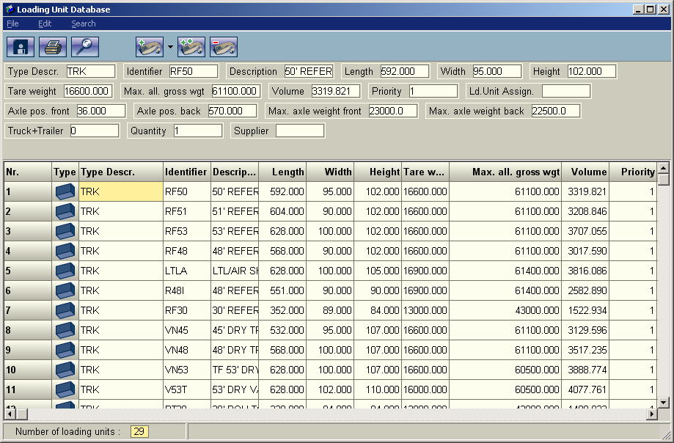

This is a listing of trailers or containers that pallets can be loaded into.

Relevant Fields:

Descr.: There are a number of types, we typically use TRK for all of our trailer types, BOX would also be acceptable.

Identifier: Must match trailer type field in the WMS, this is the identifier that we send to palletctl to instruct it on which trailer to use.

Description: A brief description of the trailer.

Length: The usable length of the trailer.

Width: The usable width of the trailer.

Height: The usable height of the trailers.

Tare Weight: The weight of the trailer empty

Max allowable gross weight: The maximum weight of the trailer and product

Volume: The maximum volume that can be occupied

Priority: What order should the trailers be used. Always set to 1 for RedPrairie
implementations as we always specify a specific trailer type.
Axle Position Front: The position of the front axle measured from the front of the trailer

Axle Position Back: The position of the back axle measure from the front of the trailer

Max Axle Weight Front: Maximum weight allowed on the front axle position

Max Axle Weight Back: Maximum weight allowed on teh back axle position

Truck+Trailer: Not Used

Quantity: The number of unit of an individual type that are available. This should always be set to 1 as currently RedPrairie does not support splitting a load across two trailers.

Supplier: Not Used

